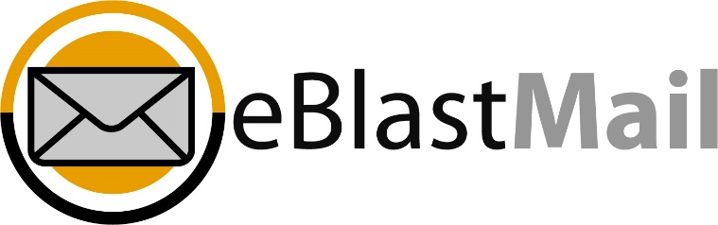
Campaign – Creating a template

By default, your eBlastMail platform does not come with a pre-made e-mail, but it does come with several pre-made templates available to customize to your liking.
From the screen you are on, click ‘Campaigns’ in the main menu.
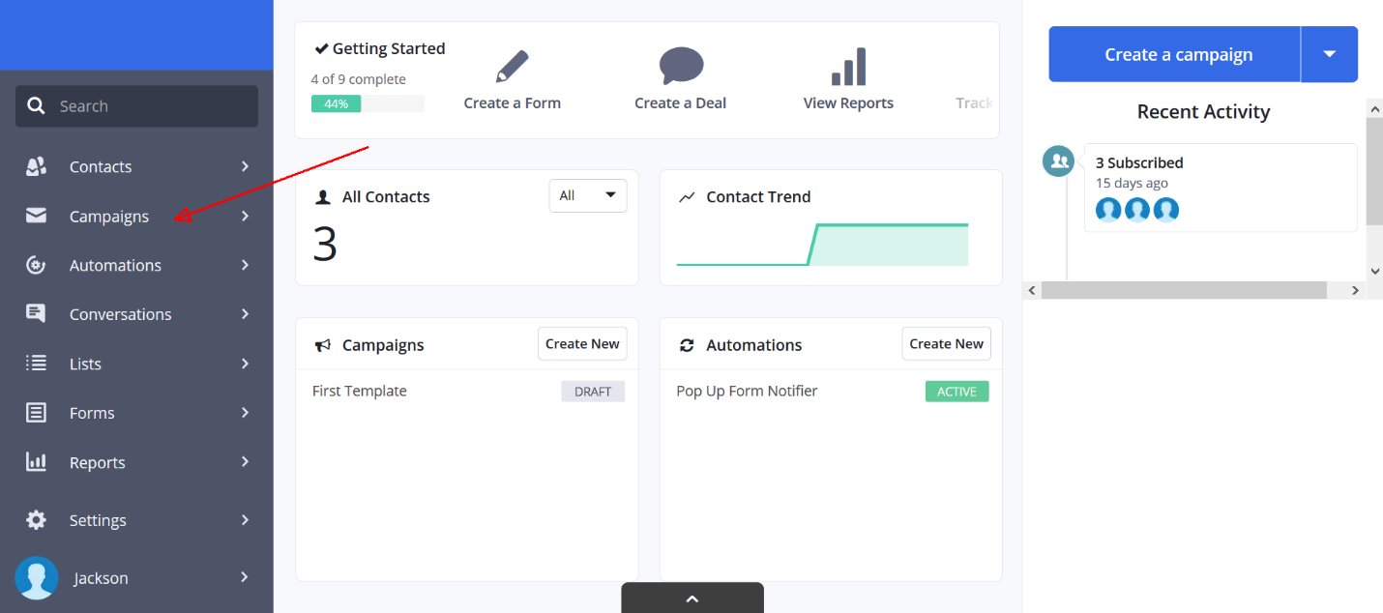
Now locate the ‘Create a campaign button in the top right of the screen and click it.
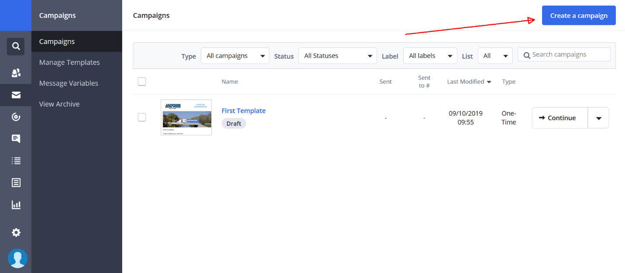
Here’s where the fun begins. At the top of your screen, you’ll see 5 tabs: Type, List, Design, Summary, and Send. For now we’ll go through the Type, List, and Design tabs.
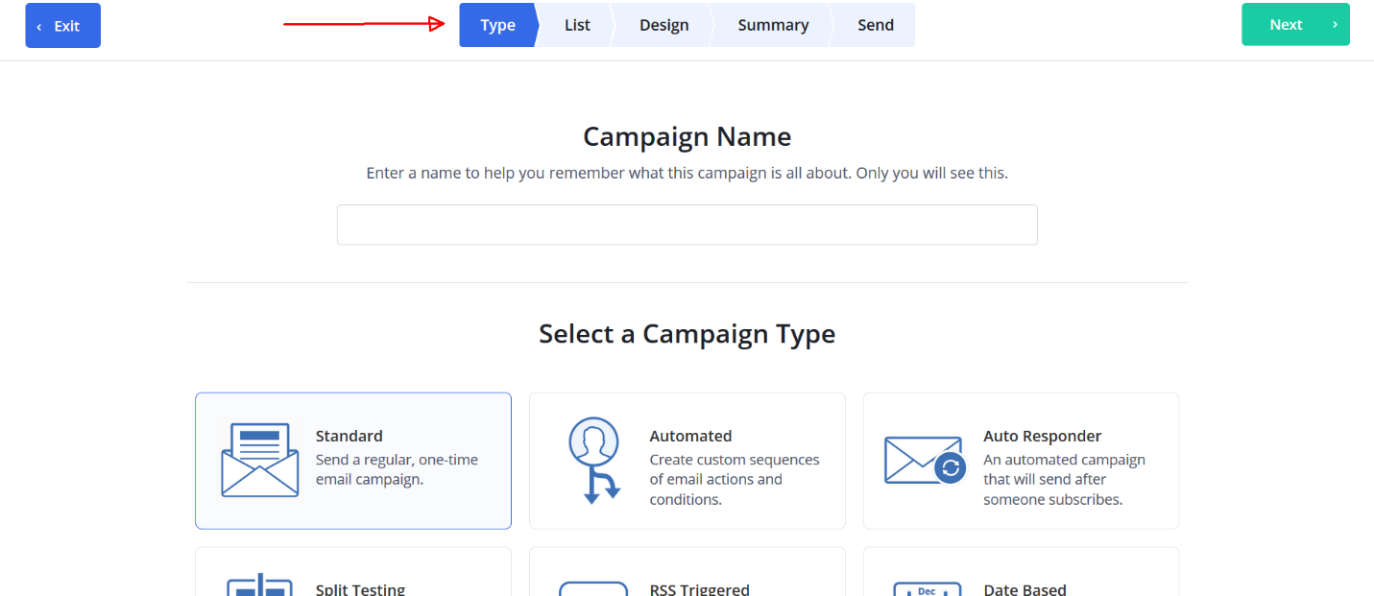
To begin, type in a Campaign name. Only you will see this, not your clients.
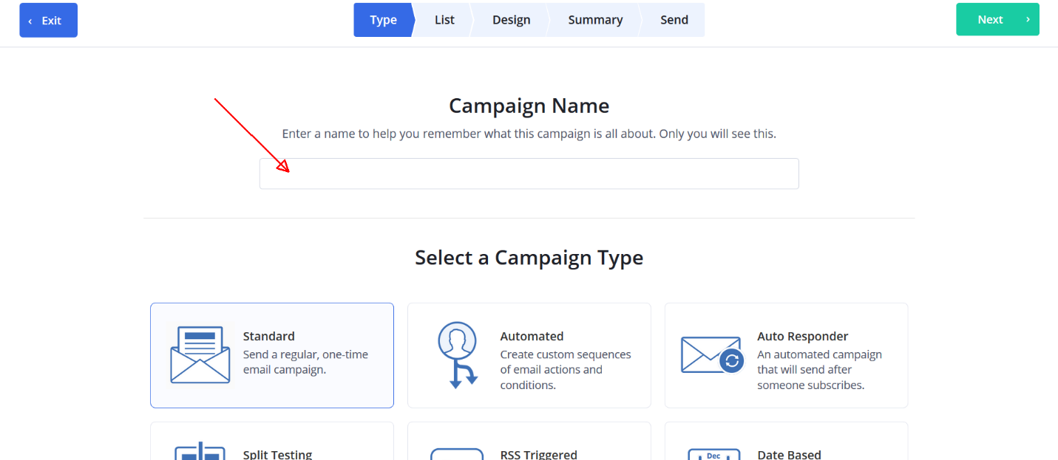
On the next screen, select your list(s)
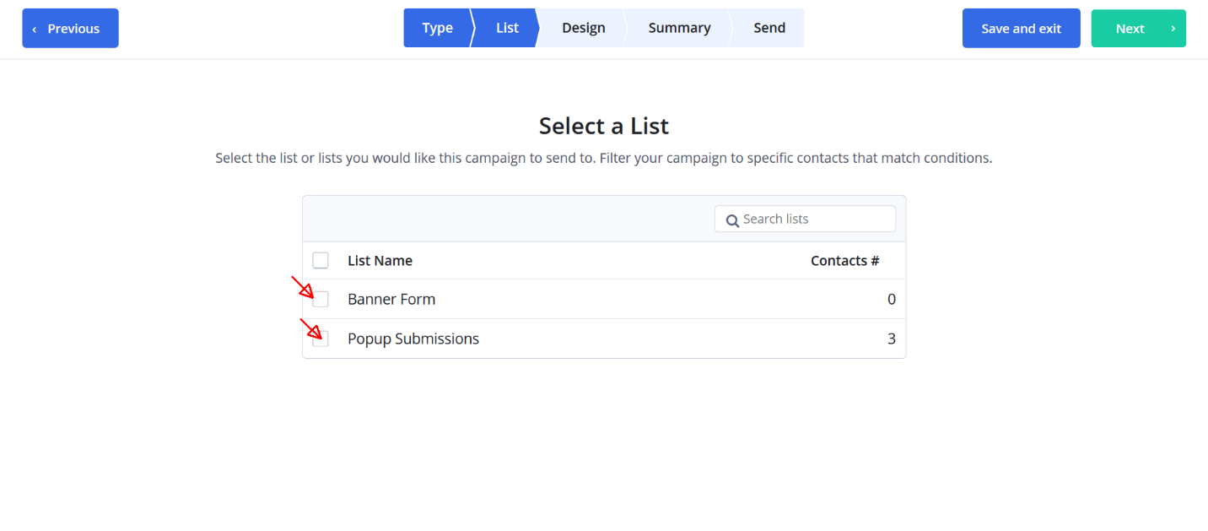
And finally, your design tab. When you create a new e-mail campaign, you’ll be presented with several pre-designed templates you can choose from. If you hover over one, you’ll see an option to use the template, or preview.
